Role of Technology

The power of data has been one of humanity's greatest and most fruitful achievements. Additionally, the importance of this data's privacy differs from organisation to organisation. And to address these data privacy issues, operationalizing a data privacy programme is frequently used. The goal of data privacy is outlined in several government rules, company policies, consumer demands, and recommendations and standards. However, the issue is that they do not offer a recommendation for how to run an effective programme.
A proactive approach to assessing and, if required, revamping the organisation’s data privacy posture will go a long way towards preparing for the new age of data protection. Three steps to ensure an organisation is well-prepared:
1. Understand and classify data: The basis of a strong data security strategy begins with identifying and classifying what type of data is collected and retained. An understanding of what personal information is processed will help establish a data inventory ready to augment data-processing activities. Where is the data stored? For how long is it stored? Who has access to it? Is it shared with any third parties? This step ensures the solid foundation needed to achieve compliance.
2. Detect and prevent leaks: Adopting an effective data loss prevention strategy can help organisations monitor and eliminate potential risks originating from emails, webpages, and endpoints. It allows the flow of information to continue while eliminating risks, protecting critical data, and ensuring compliance. The data loss prevention strategy doesn’t need to become a barrier to business processes if implemented in an adaptive manner that doesn’t put a stop to communication but rather automatically removes any sensitive or malicious data as it enters or exits the network.
3. Secure personal data: After the organisation has ensured that personal data is classified and potential risks are removed, the data then needs to be protected both at rest and when it’s being shared in order to achieve true end-to-end data security. This can be done by implementing encryption at rest, email encryption, a managed file transfer (MFT) solution, or a combination of these technologies. An MFT solution protects sensitive data when it’s most vulnerable—while being accessed by others and while being sent to unmanaged domains, devices, or applications. It creates a secure channel with a central platform for information exchange while providing audit trails, user access controls, and other file transfer protections.
Technology plays can play a key role in achieving each of the above objectives. However, before designing a strategy for the above, we need to understand the biggest challenges one organization might face in data privacy and protection.
- The exponential growth of data:
Data is expanding at an astronomically rapid rate. Every second that goes by, more than 1.7 gigabytes of new data are produced; as a result, businesses must continue to secure both their own sensitive personal information and the private data of their customers. A public tracking website for data breaches, Breach Level Index, says that since 2013, almost 9,198,580,293 data records have been lost or stolen. Data has grown incredibly quickly over the past ten years, yet security procedures have remained subpar, putting organisations at danger of data breaches. In terms of data privacy, personally identifiable information is one of the major worries (PII). Today's technology-driven, fast-paced society has made handling large amounts of data burdensome for everyone due to the high volume and validity of the data.

- High Cost of Maintaining Data Privacy:
A data breach can result in the loss of millions or even billions of dollars in revenue. The Ponemon Institute also discovered that in 2017, the average cost of a data breach was approximately $3,000,000. Additionally, any given organisation has a 30% chance of experiencing a data breach within the next two years. Intense regulatory penalties from an array of entities is faced by an organisation if the data is exposed.
For instance, businesses based in the European Union (EU) that had a significant breach due to lax security measures may be subject to fines of up to 5% of adjusted gross sales, or 20,000,000 pounds, whichever is larger. To guarantee that their data is protected, backups are made, and redundant infrastructure is in place, organisations must invest in a number of essential security solutions.
- No. of Open Vulnerabilities
A cyber security vulnerability generally refers to a flaw in software code that allows an attacker access to a network or system. There is a huge range of possible vulnerabilities and potential consequences to their exploits. The US government’s National Vulnerability Database (NVD) which is fed by the Common Vulnerabilities and Exposures (CVE) list currently has over 176,000 entries.

Half of internal-facing web application vulnerabilities are considered high risk:
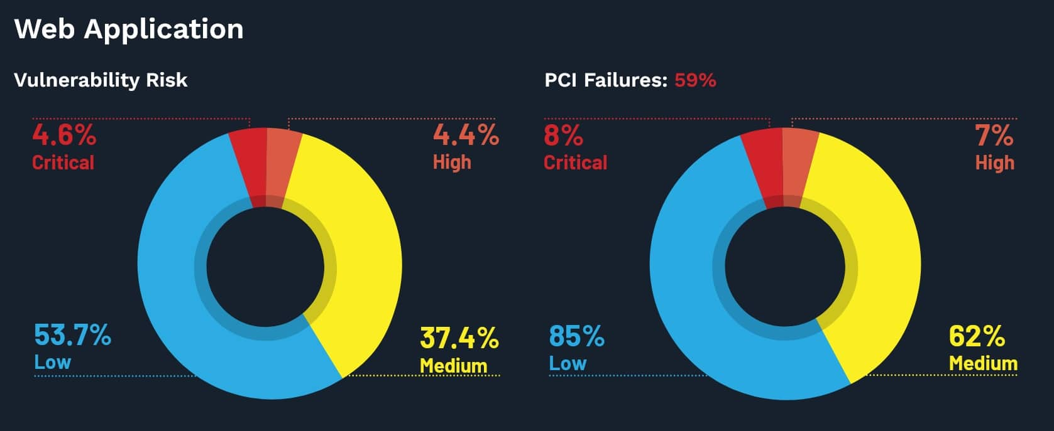

Nonetheless to say, the bigger the size of the organization, the greater the risk to critical vulnerabilities. Also the MTTR (mean time to reduction) of these vulnerabilities is 58 days which is a considerably long period given the criticality of the risk.

Best mitigation practices:
A privacy culture will instil in your staff and other business partners an understanding of why data privacy should be respected and how it can be done. The recommended practises listed below can assist you in starting your path toward a privacy-friendly culture.

- Practicing minimal data collection:
One should only gather the data they actually require. Make a list of alternatives for handling personal data collection while it is being done. Where appropriate, this might involve employing a "verify not store" approach. As soon as the user's input has been verified as being from them and that they are who they claim to be using this sort of system, little to no real data has to be saved.

- Keeping the flow both ways:
Privacy can undoubtedly be used as a way to interact with clients and demonstrate your respect for their personal data. The goal of the new data laws is to make the use of permission a key component of data collection and usage. Every time someone collects or uses data, they should incorporate consent models into the user experience and corresponding user interface (UI) they develop.

- Robust data security:
The freedom to decide whether or not to disclose data is just one aspect of privacy. However, security measures must be put in place in order to use these options and safeguard the underlying data. Security must be implemented across various layers, especially in cloud-based applications. Understanding and accurately categorising your data are the first steps towards achieving this. Is it private information? Will it require more defences? Therefore, one should look at methods like database protection, privileged access management (PAM), encryption, and credential selection and management.

- Designing policies and agreements with third parties:
Privacy is unquestionably a system-wide effort, that much is certain. Therefore, there is a potential impact on privacy at every point of contact inside a company, across all of its services, and in how it handles data and manages customers. Reaching out to the larger vendor ecosystem for information on security and privacy practises should be a priority.

